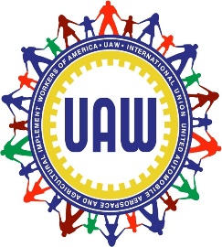Local 1264 SSP

April 9, 2022

Stellantis most recently informed The International Union that they will no longer be providing bottled drinking water at any of their facilities. (Previously. the bottled water was mutually agreed upon by both International and Corporate to be provided to our members during Covid). However, the company will still be required to provide bottled water to UAW Local 1264's members on those contractual days agreed upon per our Local Contract Agreement.
In Solidarity,

LaShawn English, President
UAW Local 1264
7450 15 Mile Rd.
Sterling Heights, MI 48312
Office 586-268-0060
Fax 586-268-0064

