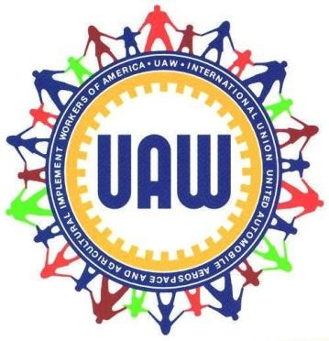

UAW LU 2200 OFFICERS 2017 - 2020

PEELE, CHRISTINE (President)

BROOKS, STACY K. (Vice President)

MASSEY, TRACY (Financial Secretary Treasurer)

HURST, PATRICIA (Recording Secretary)

Vacant (Sgt. at Arms)

MANTY, DOROTHY (Guide)

(Trustee)

LOTHARP, ANNETTE (Trustee)

UNIT - APL (ASSOCIATION OF PROFESSIONAL LIBRARIANS)

NAIRN, INA SUE (Unit Chair)

HAWKINS, BARBARA (Steward, Westside)

VORTKAMP, MARY JO (Steward, Eastside)

BATCHELDER, JANET (Steward, Main Library)

KORDYBAN, MARY (Unit Secretary)

UNIT – POOL (PROFESSIONAL ORGANIZATION OF LIBRARIANS)

Fazekas-Hardy Stephanie (Unit Chair)

Vacant (Steward, Westside)

PYCIAK, MICHAEL (Steward, Eastside)

Jones, DeAidre (Steward, Old Main)

MORTON, ROGER (Steward, New Main)

GOSS, QUIMISHA (Unit Secretary)

UNIT - STU (SKILLED TRADES UNIT)
SOWINSKI, RICHARD D. (Unit Chair)

Brian Myers (Steward)

Vacant (Unit Secretary)

Revised 4/22/20

