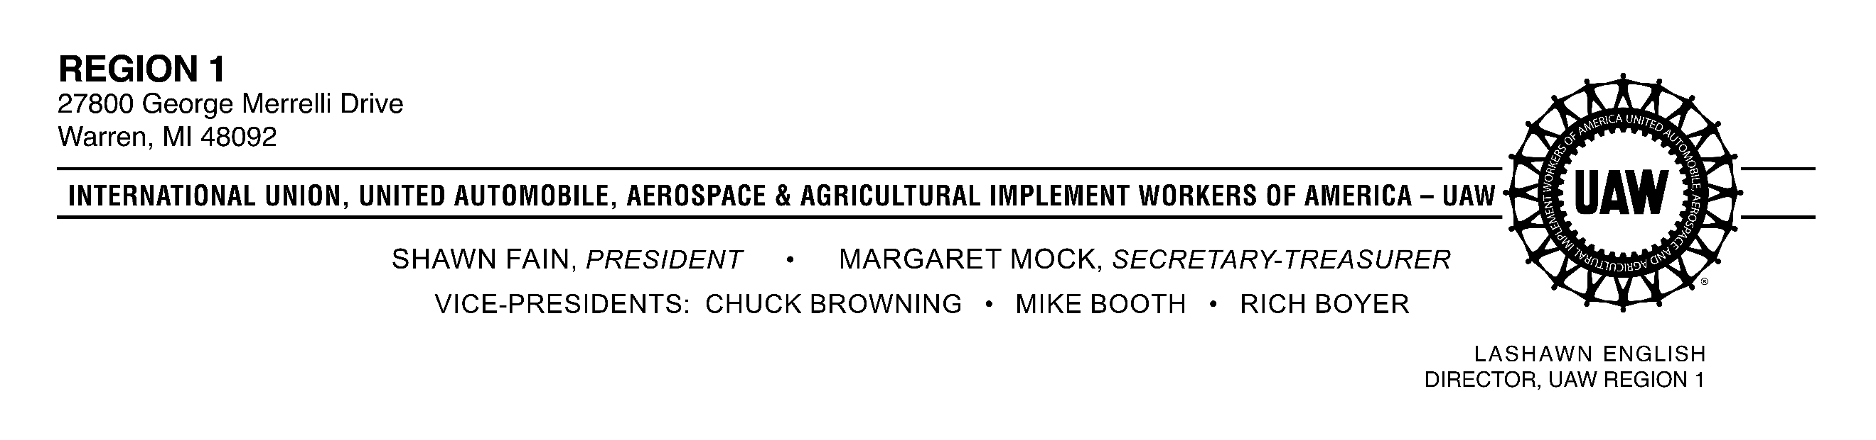

February 3, 2025
Via Email

To: UAW Region 1 Local Union Presidents, Financial Secretaries and
Retiree Chapter Chairpersons

Re: UAW Region 1 Retiree Seminar
Walter and May Reuther UAW Family Education Center, Black Lake
May 12-15, 2025

Greetings:

UAW Region 1 has scheduled a retiree seminar for four days at the Walter and May Reuther
UAW Family Education Center.

This retiree seminar is open to all UAW retirees, his or her spouse, guests and associate status members. The cost of this seminar is $350 per person. The region will pay $250 each for up to three (3) UAW Region 1 retiree delegates from every interested local union, leaving a balance due of $100 for each of the three delegates to be paid by each delegate. All spouses, guests and associate status members must pay the full $350 registration fee.

Reservations that are cancelled seven days or more prior to arrival will not be charged. Cancellations occurring less than seven days prior to arrival will be charged.

We are limited to 150 participants, and we are only reserving one bus. It will be filled on a first-come, first-served basis.

Each chapter should complete and send the enclosed registration form(s) (which may be duplicated) to Rita Yancy, UAW Region 1, 27800 George Merrelli Drive, Warren, MI 48092, no later than Thursday, March 27th. All checks must come from the local union made payable to “International Union, UAW” and should be accompanied by the registration forms for each chapter’s delegates. Please have the retirees who are paying for themselves, their spouse, guests or associate members, make their payments to the local union and have the local union issue a check to “International Union, UAW.” No personal checks will be accepted.

Make sure you indicate on the enclosed registration form(s) whether those participating in the retiree seminar will be riding the bus or driving. Also, please notify those members who are taking the bus, that the buses will depart from Region 1 headquarters on May 12th, at 9:30 a.m. and will return on the afternoon of May 15th. The region is located south of Twelve Mile Road, west of Van Dyke off of Tank Avenue (11 ½ Mile Road).

If anyone has a medical condition(s) that requires them to eat, drink or take medication at a certain time, they should bring the necessary food, beverages or medication on the bus with them, as the bus may not make stops at the time it is required for them to take care of their personal needs.

Additionally, members should be informed that they may participate in the following events:

- Day trips to area casinos
- Bingo
- Guest speaker(s) at Black Lake – Tuesday and Wednesday mornings

They should bring extra money if they plan to attend these activities. Room assignments will be made immediately upon arrival and dinner will be served at 6 p.m. We will meet after dinner to outline the activities for our program. We will leave Black Lake after breakfast on May 15th, at 9:30 am.

Please submit the names of your delegates and fees by the deadline date of March 27th. Confirmation letters will be mailed to the delegates. If you have any questions, feel free to contact Rita Yancy at (586) 427-9200.

Have a pleasant trip.

In solidarity,

LaShawn English, Director
UAW Region 1

LE/RY:sa
opeiu494/afl-cio
Attachment
NP/Retirees/2025/Retiree Seminar/Retiree Seminar Call Letter 2025
cc: Ray Pecoraro, Assistant Director, UAW Region 1
Rita Yancy, Retiree Support Staff, UAW Region 1

